2020 Summer Camps Dates and Locations – The First Tee of Phoenix
Each Course will have 2 camps per week
Early Morning: 7:30 am - 9:00am (12 member limit)
Late Morning: 9:45am - 11:15am (12 member limit)
Week 1 (June 8 - 11) **PLAYer Week**
- Papago - Early and Late Morning
- Talking Stick - Early and Late Morning
- Wigwam - Early and Late Morning
Week 2 (June 15 - 18) **Tournament Readiness Week**
- Aguila - Early and Late Morning
- Desert Mirage - Early and Late Morning
- Palo Verde - Early and Late Morning

Week 3 (June 22 - 25) **PLAYer Week**
- Augusta Ranch - Early and Late Morning
- Papago - Early and Late Morning
- Wigwam - Early and Late Morning

Week 4 (July 6 - 9) **Tournament Readiness Week**
- Desert Mirage - Early and Late Morning
- Lone Tree - Early and Late Morning
- Papago - Early and Late Morning

Week 5 (July 13 - 16) **PLAYer Week**
- Briarwood - Early and Late Morning
- Lone Tree - Early and Late Morning
- Talking Stick - Early and Late Morning

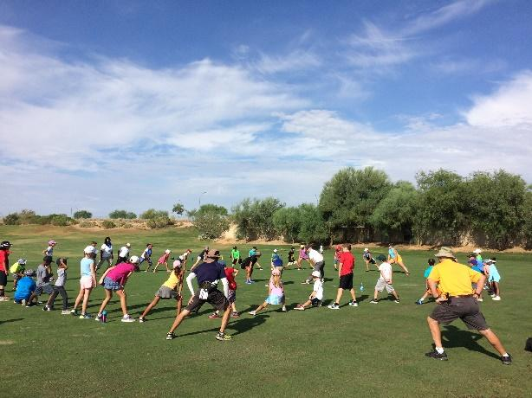
Week 6 (July 20 - 23) **Tournament Readiness Week**
- Desert Mirage - Early and Late Morning
- Longbow - Early and Late Morning
- Palo Verde - Early and Late Morning

